Consider the power of kindness
Being kind to someone, even if it is simple, can make a huge difference to someone’s day. During this time the small acts of kindness we used to do every day without thinking are more difficult to do safely with social distancing in place.
Now we must think about how we can be kind to those far away from us.
Many people have been displaying extraordinary acts of kindness like safely delivering food to people, offering free meals to key workers, or making protective clothing for health workers.
However big or small the kind acts we can do are, they can make a huge difference to someone, such as writing and sharing a message of support.
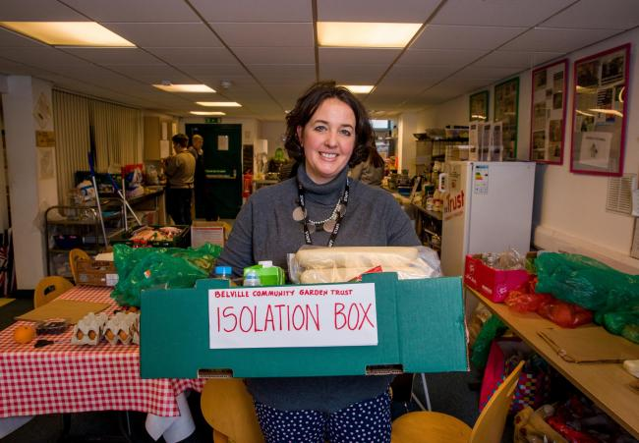
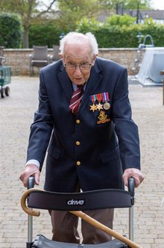

Task:
- Draw a picture of a heart on a piece of paper.
- Now think of all kind acts people do for you and on one side of the heart colour in a
patch of your heart, a different colour for each act. Things like when your sibling
plays with you or your parent or carer cooks food that you like.
- Add all the kind things that you do for other people that also make you happy on the
other side of the heart. Maybe you call your grandparents or tidy up all your toys.
Keep going until your heart is full.
- Think about how kindness can fill up your heart. Imagine how your kind acts fill up
the hearts of others.
Below I have started an example.

